Chapter 7: Cellular Respiration: Harvesting Chemical Energy
Outline
- Cellular respiration and fermentation are catabolic (energy -yielding) pathways  - Cells must recycle the ATP they use for work  - Redox reactions release energy when electrons move closer to electronegative atoms  - The "fall" of electrons during respiration is stepwise, via NAD⁺ and an electron transport chain  - Electrons from food stored by NADH reach O₂ in the electron transport chain  - Overview of cellular respiration  - The cell makes ATP by two mechanisms:Glycolysis oxidizes glucose to pyruvate  - Krebs cycle Completes energy-yielding oxidation of organic molecules  - The inner mitochondrial membrane couples electron transport to ATP synthesis  - The pathway of electron transport  - Review of Cellular respirationFermentation enables some cells to produce ATP without the help of O₂  - Glycolysis and Krebs cycle connect to manny other metabolic pathways  - Feedback mechanisms control cellular respiration | 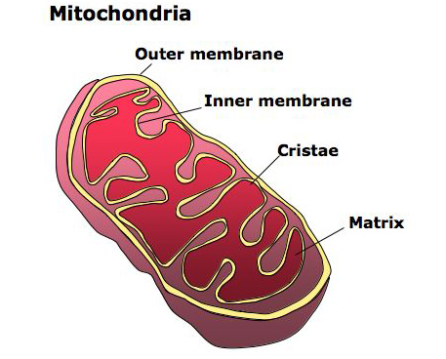
All cells require energy to carry out normal life processes. Ultimately, all energy enters most ecosystems as sunlight captured by photosynthetic organisms. Animals obtain energy and a source of carbon by eating plants and other animals. This chapter looks at how cells harvest the chemical energy stored in organic molecules and use it to regenerate ATP.
Cellular respiration and fermentation are catabolic (energy -yielding) pathways
- Organic molecules store energy in their arrangement of atoms. With the help of enzymes, cells systematically degrade complex organic molecules that are rich in potential energy to simpler waste products that have less energy. Some of this energy can be harvested to do work.
- Catabolic pathways = metabolic pathways that release stored energy by breaking down complex molecules.
- Cellular respiration = most prevalent and efficient catabolic pathway whereby oxygen is consumed as a reactant along with organic fuel.
- Overall process summarized as follows:
  - Organic compounds + Oxygen ----------> Carbon dioxide + water + Energy
- Although all macromolecules can be used as a source of fuel, glucose is traditionally used to learn the steps of cellular respiration.
  - C₆H₁₂O₆ + 6O₂ ---------> 6CO₂ + 6H₂0 + Energy (ATP + heat)
- This reaction is exergonic (ΔG = -686 kcal/mol).
- Catabolism is linked to work by a chemical drive shaft: ATP
Cells must recycle the ATP they use for work
- Cells tap energy in ATP by using enzymes to transfer phosphate groups from ATP to other compounds (phosphorylation).
- These phosphorylated compounds are primed to undergo some kind of change that performs work, with the molecule becoming dephosphorylated in the process (Fig 9.2).
- Three types of cellular work:
  - 1. Transport
  - 2. Mechanical
  - 3. Chemical
- ATP is consumed at a very fast rate and must be regenerated. A working muscle cell recycles 10 million ATP molecules per second.
Redox reactions release energy when electrons move closer to electronegative atoms
- Chemical reactions of cellular respiration involve the transfer of electrons. The relocation of electrons releases energy stored in food molecules, and this energy is used to synthesize ATP.
- These electron transfers are called oxidation-reduction reactions (redox reactions).
  - oxidation = loss of electrons from a substance.
  - reduction = addition of electrons to another substance
  - reducing agent = electron donor
  - oxidizing agent = electron acceptor
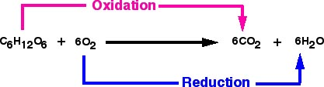
- Since electron transfer requires a donor and acceptor, oxidation and reduction always occur together.
- Oxygen is very electronegative and thus a potent oxidizing agent.
- An electron loses potential energy when it shifts from a less electronegative atom toward a more electronegative one. A redox reaction that relocates electrons closer to oxygen releases chemical energy that can be put to work.
- Respiration is essentially an energy-yielding redox process.
- As in the conbustion of methane, glucose is oxidized and oxygen is reduced, and the electrons lose potential energy along the way (Fig 9.3).
- Organic molecules that have an abundance of hydrogen are excellent fuels because their bonds are a source of "hilltop" electrons with the potential to "fall" closer to oxygen. The change in the covalent status of electrons as hydrogen is transferred to oxygen is what liberates energy.
The "fall" of electrons during respiration is stepwise, via NAD⁺ and an electron transport chain
- Cellular respiration does not oxidize glucose in a single explosive step , but gradually in a series of steps, each catalyzed by an enzyme.
- Hydrogen (proton + electron) atoms stripped from glucose are passed to molecules of intermediate electronegativity before being passed to oxygen.
- Hydrogens first passed on to a coenzyme called NAD⁺ (Nicotinamide adenine dinucleotide (Fig 9.4).
- NAD⁺ traps electrons from glucose using enzymes called dehydrogenases, which remove a pair of hydrogen atoms from the substrate. The enzyme delivers the two electrons along with one proton to its coenzyme, NAD⁺, which becomes reduced to NADH. The other proton is released into the surrounding solution.
- NAD⁺ is the most versatile electron acceptor in cellular respiration and functions in many redox reactions during the breakdown of sugar.
- Electrons lose very little potential energy when transferred to NAD⁺. Each NADH molecule formed during respiration represents stored energy that can be tapped to make ATP when the electrons complete their "fall" from NADH to oxygen.
Electrons from food and stored by NADH reach O₂ in the electron transport chain
- ETC breaks the fall of electrons to oxygen into several energy releasing steps (ATP + heat), instead of one explosive reaction (Fig 9.5).
- ETC consists of three clusters of molecules, mostly proteins, built into the inner membrane of the mitochondria.
- Electrons removed from food are shuttled by NADH to the top end of the chain. At bottom end, O₂ captures these electrons along with H⁺ to form water.
- Electrons keep moving along the chain because each carrier is more electronegative than the previous carrier, until finally electrons reach O₂.
- During cellular respiration, most electrons travel this "downhill" route: Food --> NADH --> ETC --> O₂.
Overview of cellular respiration
- Respiration is a cumulative function of 3 metabolic pathways (Fig 9.6):
  - 1. Glycolysis
  - 2. The Krebs Cycle
  - 3. Electron Transport Chain
- Both glycolysis and Krebs have some redox reactions in which a dehydrogenase transfers electrons from food substrates to NAD⁺ to form NADH.
The cell makes ATP by two mechanisms:
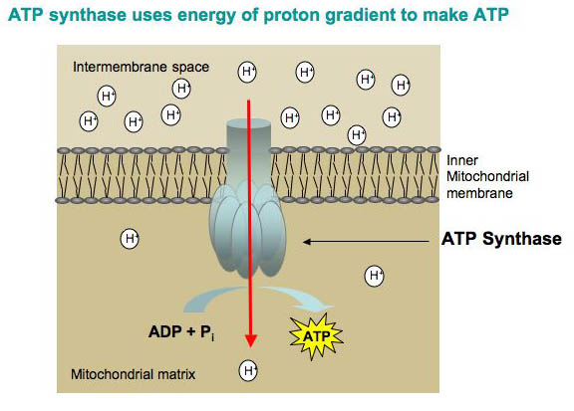
Oxidative phosphorylation
- mode of ATP synthesis powered by redox reactions that transfer electrons from food to O₂.
accounts for 90% of ATP generated by respiration

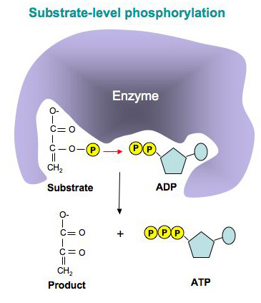
Substrate level phosphorylation
- Enzymatic transfer of phosphate group directly from food molecules to ADP to form ATP (fig 9.7).
Glycolysis oxidizes glucose to pyruvate
- Splits glucose (6C) into two 3-carbon sugar molecules which are then rearranged and oxidized to 2 pyruvate molecules (Fig 9.8 and 9).
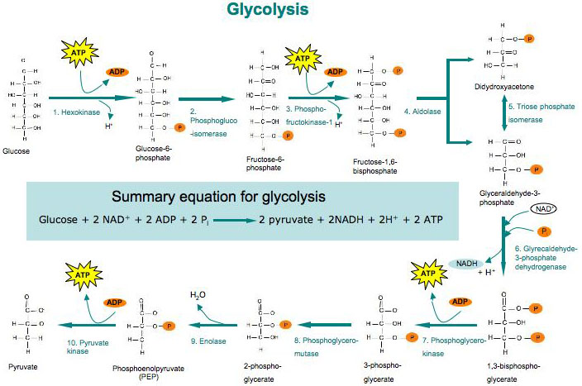
- Occurs via 10 steps, each catalyzed by a specific enzyme.
- 2 phases:
  - 1. Energy investment phase (ATP used up)
  - 2. Energy payoff phase
- ATP produced by substrate level phosphorylation and NAD⁺ reduced to NADH.
- Glycolysis is anaerobic.
- Occurs in cytosol.
- Source of ATP + NADH
- Refer to Fig 9.9
- Net reaction
  - glucose to 2 pyruvates + 2 H₂O
  - 2ADP + 2P_{i} to 2 ATP
  - 2 NAD⁺ to 2 NADH + 2H⁺
- Note: all carbons present in glucose still present in pyruvate. Also, glycolysis occurs whether or not O₂ is present.
Krebs cycle Completes energy-yielding oxidation of organic molecules
- The Krebs Cycle (a.k.a. Citric Acid Cycle) occurs in mitochondrial matrix. Takes derivative of pyruvate and breaks it down into CO₂.
- Glycolysis releases less than 25% of chemical energy stored in glucose. Most still stored in 2 molecules of pyruvate.
- Krebs cycle completes the energy yielding oxidation stocked in pyruvate.

- Upon entering mitochondria, pyruvate is first converted to acetylCoA in 3 simultaneous steps (Fig 9.10):
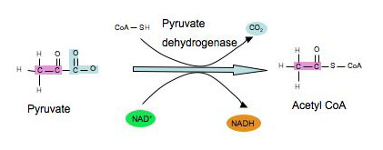
  - 1. carboxyl group of pyruvate removed as CO₂, which diffuses out of cell.
  - 2. the 2-carbon molecule is oxidized and NAD⁺ is reduced to NADH.
  - 3. acetyl group (2C) attached to CoenzymeA (CoA). CoA has S atom, which attaches to acetyl fragment by an unstable bond (i.e reactive).
  - Acetyl CoA then enters the Krebs Cycle.

- Krebs cycle involves 8 enzymatic steps (Fig 9.11).
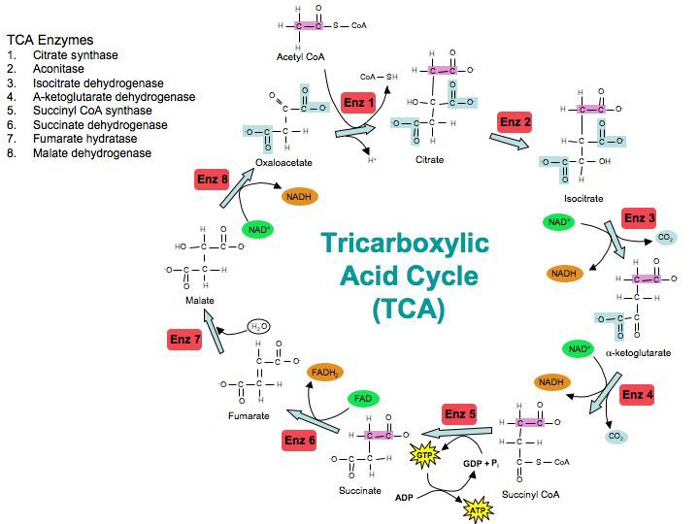
- 2 carbon molecules enter as a relatively reduced acetylCoA which gets enzymatically added to oxaloacetate to form citrate (6 carbons)
- citrate gets decomposed into oxaloacetate (regenerated) and CO₂.
- Most energy harvested by oxidation steps of Krebs is conserved as NADH.
- For every acetylCoA, 3 NADH + 1 FADH₂ + 1 ATP are produced.
- NADH and FADH₂ shuttle electrons into the ETC whereby ATP is produced by oxidative phosphorylation.
- Krebs cycle is like a metabolic "furnace", oxidizing organic fuel derived from pyruvate in a controlled combustion reaction.
The inner mitochondrial membrane couples electron transport to ATP synthesis
- So far glycolysis and Krebs cycle have only produced 4 ATP per glucose by substrate level phosphorylation.
- Most of the energy extracted from glucose is still in the form of NADH and FADH₂. These electron carriers link glycolysis and Krebs cycle to the ETC to power ATP synthesis.
The pathway of electron transport
- ETC is a collection of protein molecules embedded in the inner membrane of the mitochondria which are arranged in order of their oxidation potential ( Fig 9.13).
- Most of the components are proteins with prosthetic groups, which alternate between reduced and oxidized states.
- Electrons removed from food in glycolysis and Krebs are transferred by NADH to the first molecule of the ETC.
- A component of the ETC becomes reduced when it accepts electrons from its "uphill" neighbor (less electronegative).
- Each member returns to oxidized state when it passes its electrons to its "downhill" neighbor.
- O₂ is the final electron acceptor.
- As electrons are passed from one molecule to another, the energy released is used to pump H⁺ (protons) into the intermembrane space, generating a H⁺ gradient (proton motive force).
- FADH₂ donates its electrons at a lower level along the ETC than does NADH. Therefore, FADH₂ has less energy than NADH.
- ETC makes no ATP directly.
Chemiosmosis (Fig 9.15).
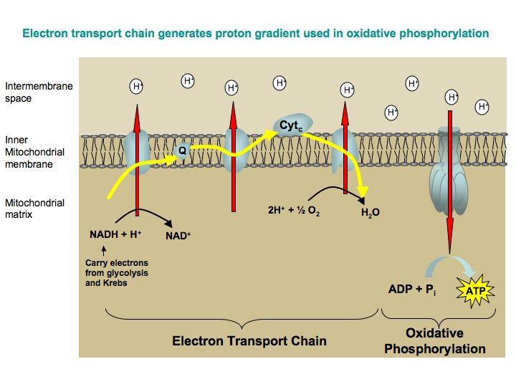
- ETC uses exergonic flow of electrons to pump H⁺ across membrane from the matrix into the intermembrane space.
- As H⁺ gradient is established, H⁺ leak back into the matrix via only available path: the ATP synthase.
- ATP Synthase = enzyme on surface of inner mitochondrial membrane that actually synthesizes ATP. Uses proton gradient as energy source (Fig 9.14).
- The ATP synthase harnesses the H⁺ gradient to phosphorylate ADP to form ATP. This is called oxidative phosphorylation because it is driven by the exergonic transfer of electrons from food to O₂.
- Chemiosmosis = use of H⁺ gradient to transfer energy from redox reactions to ATP.
Review of Cellular respiration

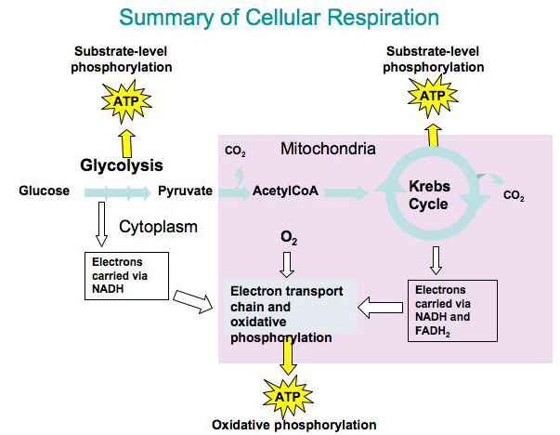
- The purpose of cellular respiration is to harvest the energy of food to form ATP (Fig 9.16).
- Each glucose yields 36 ATP
- 2 ATP glycolysis (substrate level phosphorylation)
- 2 ATP Krebs (substrate level phosphorylation)
- -2 ATP cost of transferring NADH from glycolysis into mitochondria
- 34 ATP oxidation phosphorylation
- Because most ATP is generated by oxidative phosphorylation, ATP yield from respiration is contingent upon availability of O₂. Without the electronegative O₂ to pull electrons down ETC, oxidative phosphorylation ceases.
Fermentation enables some cells to produce ATP without the help of O2
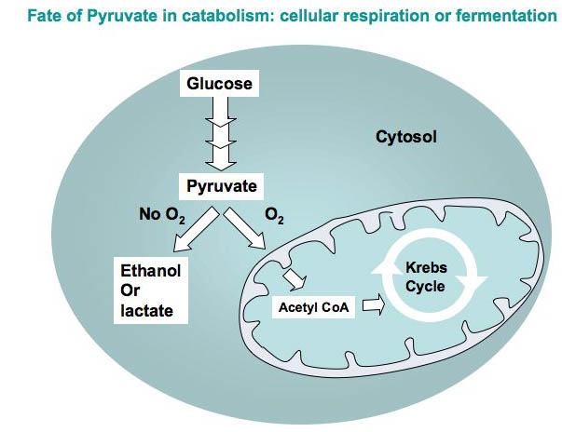
- When O₂ is present, additional ATP is made by oxidative phosphorylation (Fig 9.18).
- In anaerobic environments, catabolism of nutrients occurs by fermentation.
- Fermentation generates ATP by substrate level phosphorylation as long as there is enough NAD⁺ to accept electrons in the oxidative steps of glycolysis.
- Fermentation consists of glycolysis + reactions that regenerate NAD⁺ by transferring electrons from NADH to pyruvate or derivatives of it (Fig 9.17)
- Alcohol fermentation
  - pyruvate converted in 2 steps:
    - 1. pyruvate to acetaldehyde + CO₂
    - 2. Acetaldehyde reduced to form ethanol + NAD⁺.
- Lactic acid fermentation
  - Pyruvate is reduced directly to lactic acid (No CO₂ given off)
Glycolysis and Krebs cycle connect to manny other metabolic pathways
- Catabolism is versatile (Fig 9.19). Carbohydrates, fats, proteins and nucleic acids can all be used for cellular respiration.
- Monomers of these food molecules enter glycolysis and Krebs cycle at various points.
- Glycolysis and Krebs cycle are catabolic funnels through which electrons from all kinds of food molecules flow on their exergonic fall to oxygen.
Feedback mechanisms control cellular respiration
- Cellular respiration is highly intricate and regulated. Regulation is controlled by allosteric enzymes at key points in glycolysis (Fig 9.20)
- Phosphofructokinase (from glycolysis) is inhibited by ATP and induced by ADP. Citrate (from Krebs) also inhibits this enzyme. This makes flux through glycolysis responsisve to flux through Krebs Cycle.
- This regulation helps control cellular respiration so that energy is not squandered. Metabollic efficiency is something that nature selects for.

